**The Superior University**



**Name:** Zeeshan Haider

**Roll No**: 065

**Section**: 4B

**Submitted to:** Sir Rasihk

**N-Queen problem**

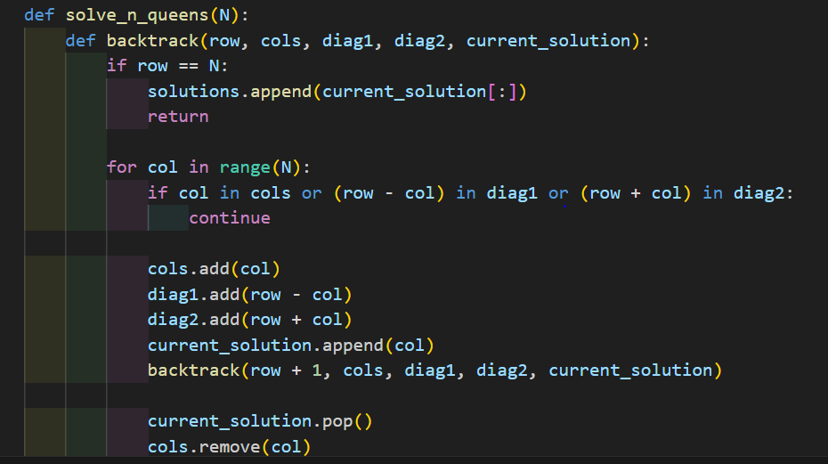

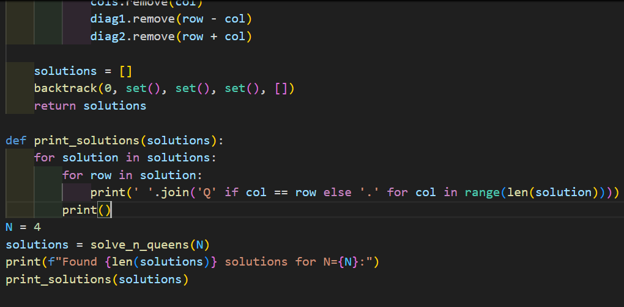

**Output:**

